Graphics:
- Custom pin drop (yourself, following, local) – Send snapshot of pins for example
  - Question pin (Q inside) – General user
  - Question pin (Q inside) – Following user
  - Question pin (Q inside) – User himself/herself
  - Question pin that hasn’t been answered (Q inside) – General user
  - Question pin that hasn’t been answered (Q inside) – Following user
  - Question pin that hasn’t been answered (Q inside) – User himself/herself
  - Answer pin (A inside) – General user
  - Answer pin (A inside) – Following user
  - Answer pin (A inside) – User himself/herself
  - Comment pin (A inside) – General user
  - Comment pin (A inside) – Following user
  - Comment pin (A inside) – User himself/herself

- Example of unique pins from Localminds iPhone app
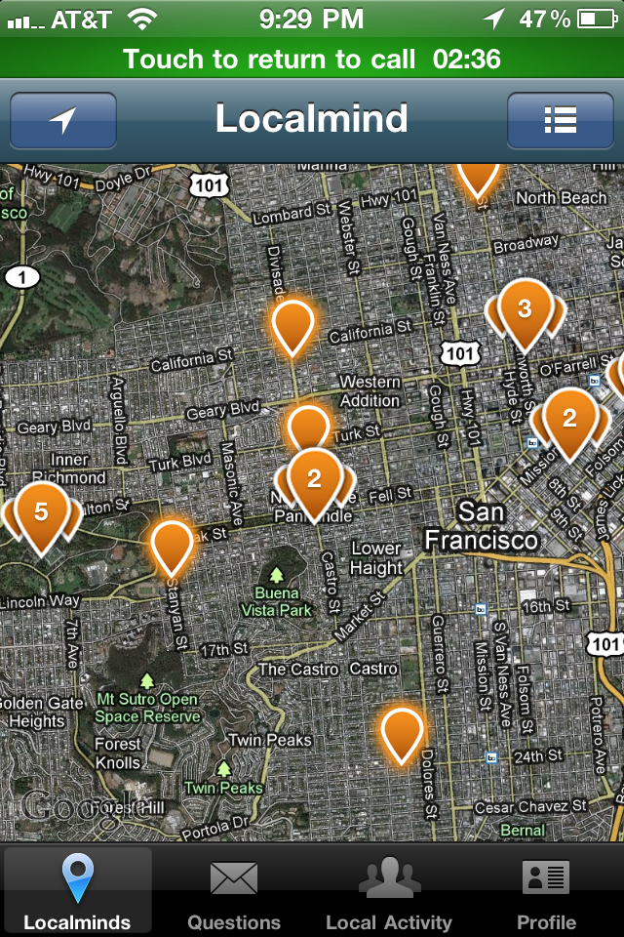

- Our current map Icon is the same as Localminds – let’s look at another variation
- App Icon
  - I like the 3D / textured look of these apps, can we look at a few mocks that incorporate this?
